SULIT



SECP2523 DATABASE

SESSION 2024/2025 - SEMESTER 1
````

ALTERNATIVE ASSESSMENT REPORT: PHASE 1

Name | IMAN ABADI BIN MOHD NIZWAN
IC No. / Matric No. | A23CS0084
Year / Program | 2/SECPH
Section | 01
Lecturer Name | Dr Rozilawati binti Dollah @ Md Zain
Case Study | Lembaga Kemajuan Pertanian Kemubu’ (KADA) Cooperative
System Name | KADA’s Cooperative Web-Based System
Group Name | AlphTech

SECTION A (SYSTEM’S OVERVIEW)

1.1 | Overall Description
 |  | << Describe the system’s overview. >>
1.2 | Project Weaknesses or Improvement
 |  | << List the project’s weaknesses or improvement that can be made to the proposed system. Provide an explanation of the proposed module to overcome the weaknesses. >>
1.3 | Proposed Module
 |  | << Describe a new module to overcome the project’s weaknesses. >>
SECTION B (DATABASE PLANNING AND DESIGN)

2.1 | Conceptual ERD
 |  | << Draw a conceptual ERD to represent the proposed module. >>
2.2 | Logical ERD
 |  | <<Provide logical ERD of your module in the proposed system.>>
2.3 | Data Dictionary for Logical ERD
 |  | << Provide the data dictionary based on the logical ERD in Subsection 2.2.>>
2.4 | Relational Database Schema
 |  | <<Provide all relations database schema of your proposed module.>>
2.5 | Normalization
 |  | << Illustrate the normalization process up until BCNF to every relation listed in 2.5. At the end of this section, list all normalized relations achieved. >>

SECTION A (SYSTEM’S OVERVIEW)
  - Overall Description
The module that I had proposed was a Financial Module which consists of 3 use cases which are View Financial Status, Update Member Share and Update Member Loans. When an employee of Lembaga Kemajuan Pertanian Kemubu (KADA) applies for a membership, they each have shares of different categories. The shares are incremented based on the number of monthly payments they agreed upon when they first registered for each share category. Members of the cooperative are also entitled to apply for loans if they have at least RM300 of shares of their share modal category. They can either pay for both their shares and loan (if any) by salary deduction or upfront payment. When the payments are made by either of the methods mentioned, the clerk of the cooperative will record those payments in the system based on the use cases Update Member Share and Update Member Loans. After the payments are recorded, the members can view their current shares and loan balance based on the paid amount which the use case of View Financial Statement. The issues faced by the cooperative was there are record issues where the payments made are hard for the cooperative to track. Furthermore, the members of the cooperative do not have live view of how much share they have and their loan balance.

  - Project Weaknesses or Improvement
The weakness of the current module is the payments are not flexible. When the admin records the payments, the payments are fixed meaning that the members cannot make additional payments if they wanted to as the values of the payments are already preset based on the monthly payments they agreed upon when they first registered for shares and monthly payments of loans based on the calculated monthly payment. Another weakness is that the members could not access the financial statement of monthly payments. Furthermore, the financial status of the members can be saved but it only displays the current share and loan amount. If the members want to save their financial status of the previous months, they are not able to.

  - Proposed Module
The new module with improvements will have record all the transactions made by the clerk. The members can view the transaction details such as the payment for which month it is for, the payment method that was done, the details of the loan and monthly loan payments, and loan balance.

SECTION B (DATABASE PLANNING AND DESIGN)

2.1 Conceptual ERD
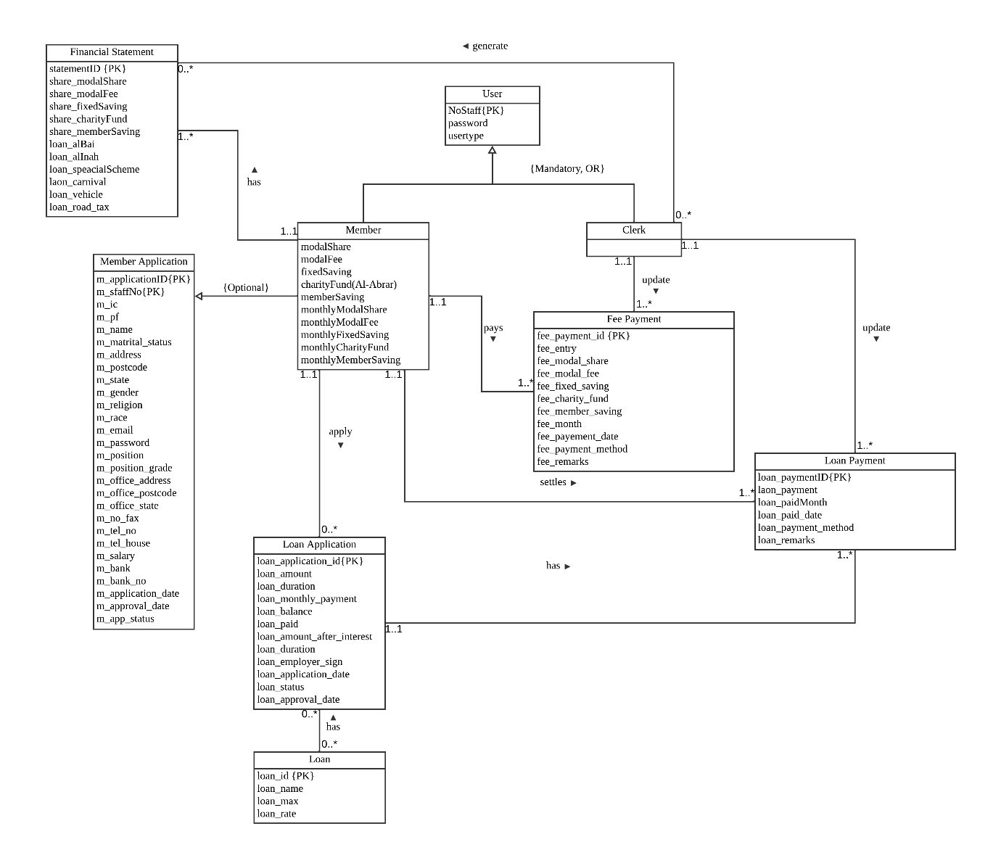

2.2 Logical ERD
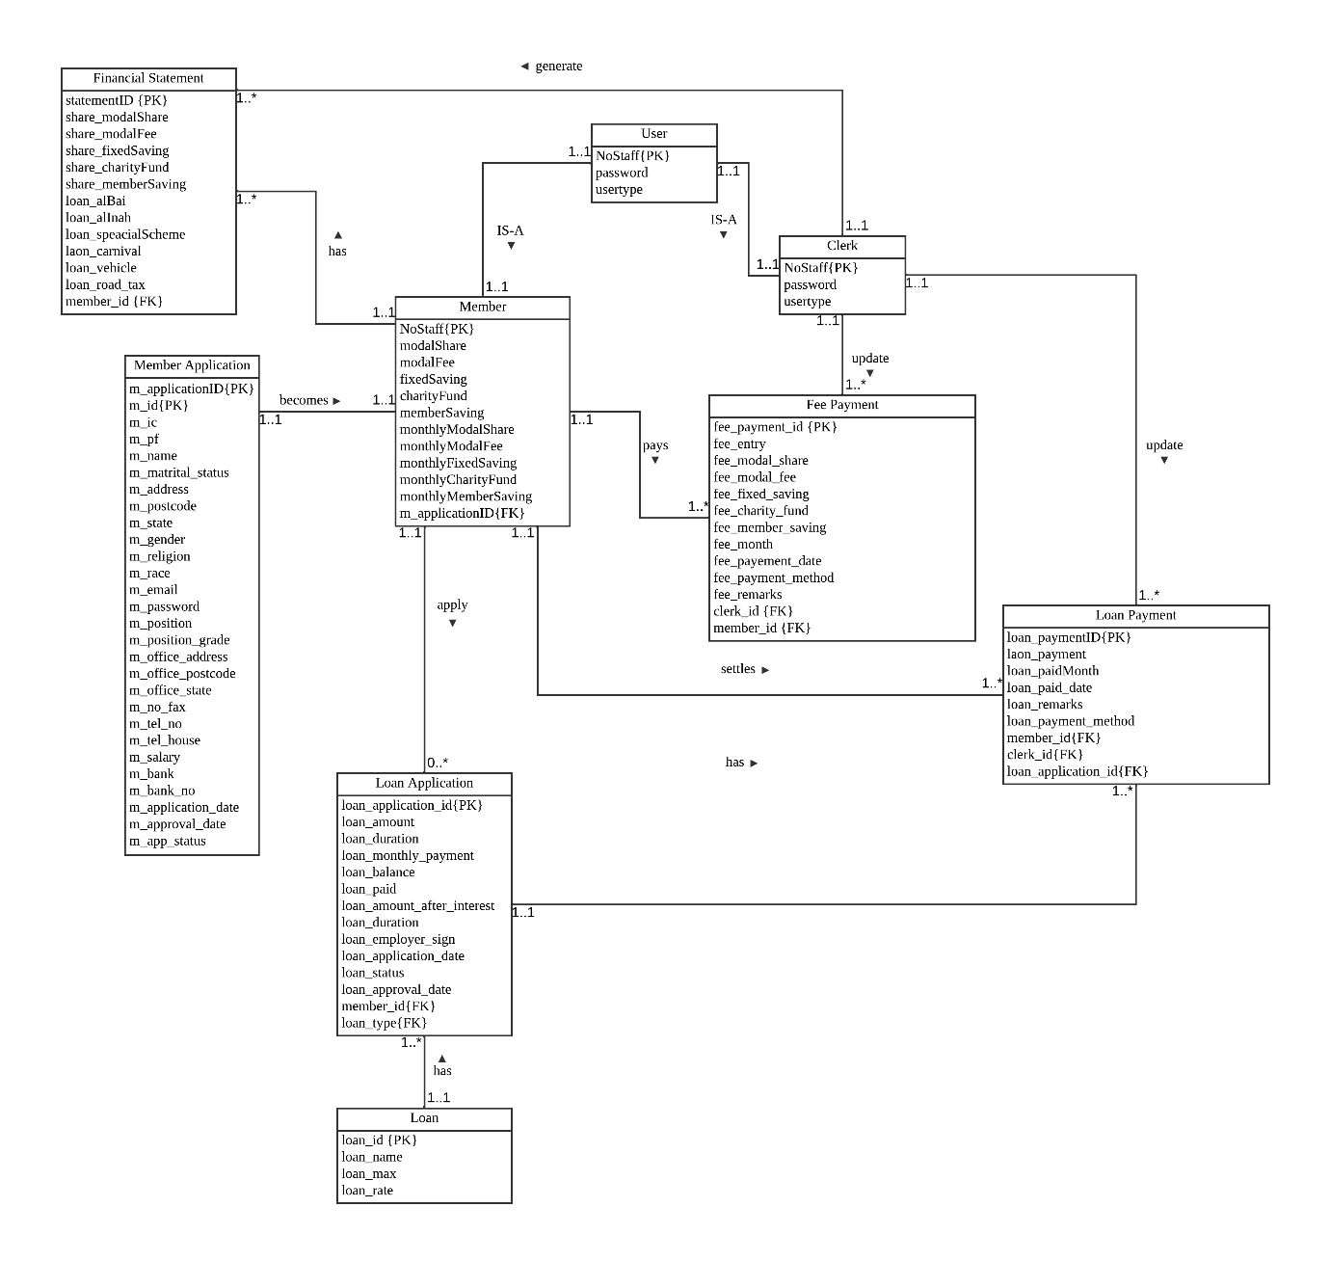

2.3 Data Dictionary for Logical ERD

Entity Name | Description | Aliases | Occurrence
User | General term describing all users using the system | None | Occurs when a user register in the system.
Member | General term describing all users logged in as a member | Staff | Occurs when a user register as a member and is approved.
Clerk | General term describing all users logged in as a clerk | Staff | Occurs when the system is built.
Membership Application | General term describing a form for users to register as a member before they can log in as a member | None | Occurs when a user tries to register to become a member in the system.
Loan Application | General term describing a form for members fill in for a loan application if they want to apply for one. | None | Occurs when a member applies for a loan.
Fee Payment | General term describing monthly payments that members pay for. | None | Occurs when users pay for the monthly fees.
Loan Payment | General term describing monthly loan payments that members apply for if there are any. | None | Occurs when users pay for the monthly loan repayment.
Financial Statement | General term describing a statement that members can view every month based on showing their shares and loan balance. | None | Occurs when there are members registered in the system and are generated every month.

Entity Name | Multiplicity | Relationship | Entity Name | Multiplicity
Member | 0..*  0..*  1..*  1..*  1..1  1..1 | apply  settles  has  pay  is from  IS-A | Loan Application  Loan Payment  Financial Statement  Fee Payment  Membership Application  User | 1..1  1..1  1..1  1..1  1..1  1..1
Clerk | 1..1  1..1  1..1  1..1 | update  generate  update  IS-A | Fee Payment  Financial Statement  Loan Payment  User | 1..*  1..*  1..*  1..1
Loan Application | 1..* | Has | Loan Repayment | 1..1
Loan | 1..* | Has | Loan Application | 1..1

2.4 Relational Database Schema

Membership Application(m_applicationID
m_id{PK}, m_ic,m_pf, m_name, m_matrital_status, m_address,m_postcode, m_state, m_gender, m_religion, m_race, m_email, m_password, m_position, m_position_grade, m_office_address, m_office_postcode, m_office_state, m_no_fax, m_tel_no, m_tel_house, m_salary, m_bank, m_bank_no, m_application_date, m_approval_date, m_app_status)

FK: m_applicationID

Member (NoStaff,modalShare, modalFee, fixedSaving, charityFund, memberSaving, monthlyModalShare, monthlyModalFee, monthlyFixedSaving, monthlyCharityFund, monthlyMemberSaving, m_ic, m_pf, m_name, m_matrital_status, m_address, m_postcode, m_state, m_gender, m_religion , m_race , m_email, m_password, m_position , m_position_grade, m_office_address, m_office_postcode, m_office_state, m_no_fax, m_tel_no ,m_tel_house, m_salary, m_bank, m_bank_no,m_application_date,m_approval_date,m_app_status m_applicationID )

PK: NoStaff
FK: m_applicationID references Membership Application (applicationID)

Financial Statement (statementID, share_modalShare, share_modalFee, share_fixedSaving, share_charityFund, share_memberSaving, loan_alBai,loan_alInah, loan_speacialScheme,l aon_carnival, loan_vehicle, loan_road_tax, member_id)

PK: statementID
FK: member_id references Member(NoStaff)

Loan Application (loan_application_id,loan_type,loan_amount,loan_duration,loan_monthly_payment,loan_balance,loan_paid,loan_amount_after_interest,loan_duration,loan_employer_sign,loan_application_date,loan_status,loan_approval_date, member_id, loan_type)

PK: loan_application_id
FK: member_id references Member(NoStaff)
FK: loan_type references Loan(loan_id)

Fee Payment(fee_payment_id, fee_entry, fee_modal_share, fee_modal_fee, fee_fixed_saving, fee_charity_fund, fee_member_saving, fee_month, fee_payement_date, fee_payment_method, fee_remarks, clerk_id {FK}, member_id)

PK: fee_payment_id
FK: clerk_id references Clerk (NoStaff)
FK: member_id references Member(NoStaff)

Loan Payment(loan_paymentID, loan_payment, loan_paidMonth, loan_paid_date, loan_remarks, loan_payment_method, member_id, clerk_id, loan_application_id)

PK: loan_paymentID
FK: member_id references Member(NoStaff)
FK: clerk_id references Clerk (NoStaff)
FK: loan_application_id references Loan Application(loan_application_ID)

Clerk(NoStaff{PK}, password, usertype)

PK: NoStaff

2.5 Normalization

Membership Application

1NF:
Membership Application(m_applicationID
m_id{PK}, m_ic,m_pf, m_name, m_matrital_status, m_address,m_postcode, m_state, m_gender, m_religion, m_race, m_email, m_password, m_position, m_position_grade, m_office_address, m_office_postcode, m_office_state, m_no_fax, m_tel_no, m_tel_house, m_salary, m_bank, m_bank_no, m_application_date, m_approval_date, m_app_status)

FK: m_applicationID

2NF:
Membership Application(m_applicationID
m_id{PK}, m_ic,m_pf, m_name, m_matrital_status, m_address,m_postcode, m_state, m_gender, m_religion, m_race, m_email, m_password, m_position, m_position_grade, m_office_address, m_office_postcode, m_office_state, m_no_fax, m_tel_no, m_tel_house, m_salary, m_bank, m_bank_no, m_application_date, m_approval_date, m_app_status)

FK: m_applicationID

3NF:
Membership Application(m_applicationID
m_id{PK}, m_ic,m_pf, m_name, m_matrital_status, m_address,m_postcode, m_state, m_gender, m_religion, m_race, m_email, m_password, m_position, m_position_grade, m_office_address, m_office_postcode, m_office_state, m_no_fax, m_tel_no, m_tel_house, m_salary, m_bank, m_bank_no, m_application_date, m_approval_date, m_app_status)

FK: m_applicationID

Member

1NF:
Member (NoStaff,modalShare, modalFee, fixedSaving, charityFund, memberSaving, monthlyModalShare, monthlyModalFee, monthlyFixedSaving, monthlyCharityFund, monthlyMemberSaving, m_ic, m_pf, m_name, m_matrital_status, m_address, m_postcode, m_state, m_gender, m_religion , m_race , m_email, m_password, m_position , m_position_grade, m_office_address, m_office_postcode, m_office_state, m_no_fax, m_tel_no ,m_tel_house, m_salary, m_bank, m_bank_no,m_application_date,m_approval_date,m_app_status m_applicationID )

PK: NoStaff
FK: m_applicationID references Membership Application (applicationID)

2NF:
Member (NoStaff,modalShare, modalFee, fixedSaving, charityFund, memberSaving, monthlyModalShare, monthlyModalFee, monthlyFixedSaving, monthlyCharityFund, monthlyMemberSaving, m_ic, m_pf, m_name, m_matrital_status, m_address, m_postcode, m_state, m_gender, m_religion , m_race , m_email, m_password, m_position , m_position_grade, m_office_address, m_office_postcode, m_office_state, m_no_fax, m_tel_no ,m_tel_house, m_salary, m_bank, m_bank_no,m_application_date,m_approval_date,m_app_status m_applicationID )

PK: NoStaff
FK: m_applicationID references Membership Application (applicationID)

3NF:
Member (NoStaff,modalShare, modalFee, fixedSaving, charityFund, memberSaving, monthlyModalShare, monthlyModalFee, monthlyFixedSaving, monthlyCharityFund, monthlyMemberSaving, m_ic, m_pf, m_name, m_matrital_status, m_address, m_postcode, m_state, m_gender, m_religion , m_race , m_email, m_password, m_position , m_position_grade, m_office_address, m_office_postcode, m_office_state, m_no_fax, m_tel_no ,m_tel_house, m_salary, m_bank, m_bank_no,m_application_date,m_approval_date,m_app_status m_applicationID )

PK: NoStaff
FK: m_applicationID references Membership Application (applicationID)

Financial Statement

1NF:
Financial Statement (statementID, share_modalShare, share_modalFee, share_fixedSaving, share_charityFund, share_memberSaving, loan_alBai,loan_alInah, loan_speacialScheme,l aon_carnival, loan_vehicle, loan_road_tax, member_id)

PK: statementID
FK: member_id references Member(NoStaff)

2NF:
Financial Statement (statementID, share_modalShare, share_modalFee, share_fixedSaving, share_charityFund, share_memberSaving, loan_alBai,loan_alInah, loan_speacialScheme,l aon_carnival, loan_vehicle, loan_road_tax, member_id)

PK: statementID
FK: member_id references Member(NoStaff)

3NF:
Financial Statement (statementID, share_modalShare, share_modalFee, share_fixedSaving, share_charityFund, share_memberSaving, loan_alBai,loan_alInah, loan_speacialScheme,l aon_carnival, loan_vehicle, loan_road_tax, member_id)

PK: statementID
FK: member_id references Member(NoStaff)

Loan Application

1NF:
Loan Application (loan_application_id,loan_type,loan_amount,loan_duration,loan_monthly_payment,loan_balance,loan_paid,loan_amount_after_interest,loan_duration,loan_employer_sign,loan_application_date,loan_status,loan_approval_date, member_id, loan_type)

PK: loan_application_id
FK: member_id references Member(NoStaff)
FK: loan_type references Loan(loan_id)

2NF:
Loan Application (loan_application_id,loan_type,loan_amount,loan_duration,loan_monthly_payment,loan_balance,loan_paid,loan_amount_after_interest,loan_duration,loan_employer_sign,loan_application_date,loan_status,loan_approval_date, member_id, loan_type)

PK: loan_application_id
FK: member_id references Member(NoStaff)
FK: loan_type references Loan(loan_id)

3NF:
Loan Application (loan_application_id,loan_type,loan_amount,loan_duration,loan_monthly_payment,loan_balance,loan_paid,loan_amount_after_interest,loan_duration,loan_employer_sign,loan_application_date,loan_status,loan_approval_date, member_id, loan_type)

PK: loan_application_id
FK: member_id references Member(NoStaff)
FK: loan_type references Loan(loan_id)

Fee Payment

1NF:
Fee Payment(fee_payment_id, fee_entry, fee_modal_share, fee_modal_fee, fee_fixed_saving, fee_charity_fund, fee_member_saving, fee_month, fee_payement_date, fee_payment_method, fee_remarks, clerk_id {FK}, member_id)

PK: fee_payment_id
FK: clerk_id references Clerk (NoStaff)
FK: member_id references Member(NoStaff)

2NF:
Fee Payment(fee_payment_id, fee_entry, fee_modal_share, fee_modal_fee, fee_fixed_saving, fee_charity_fund, fee_member_saving, fee_month, fee_payement_date, fee_payment_method, fee_remarks, clerk_id {FK}, member_id)

PK: fee_payment_id
FK: clerk_id references Clerk (NoStaff)
FK: member_id references Member(NoStaff)

3NF:
Fee Payment(fee_payment_id, fee_entry, fee_modal_share, fee_modal_fee, fee_fixed_saving, fee_charity_fund, fee_member_saving, fee_month, fee_payement_date, fee_payment_method, fee_remarks, clerk_id {FK}, member_id)

PK: fee_payment_id
FK: clerk_id references Clerk (NoStaff)
FK: member_id references Member(NoStaff)

Loan Payment

1NF:
Loan Payment(loan_paymentID, loan_payment, loan_paidMonth, loan_paid_date, loan_remarks, loan_payment_method, member_id, clerk_id, loan_application_id)

PK: loan_paymentID
FK: member_id references Member(NoStaff)
FK: clerk_id references Clerk (NoStaff)
FK: loan_application_id references Loan Application(loan_application_ID)

2NF:
Loan Payment(loan_paymentID, loan_payment, loan_paidMonth, loan_paid_date, loan_remarks, loan_payment_method, member_id, clerk_id, loan_application_id)

PK: loan_paymentID
FK: member_id references Member(NoStaff)
FK: clerk_id references Clerk (NoStaff)
FK: loan_application_id references Loan Application(loan_application_ID)

3NF:
Loan Payment(loan_paymentID, loan_payment, loan_paidMonth, loan_paid_date, loan_remarks, loan_payment_method, member_id, clerk_id, loan_application_id)

PK: loan_paymentID
FK: member_id references Member(NoStaff)
FK: clerk_id references Clerk (NoStaff)
FK: loan_application_id references Loan Application(loan_application_ID)

Clerk

1NF:
Clerk(NoStaff{PK}, password, usertype)

PK: NoStaff

2NF:
Clerk(NoStaff{PK}, password, usertype)

PK: NoStaff

3NF:
Clerk(NoStaff{PK}, password, usertype)

PK: NoStaff

